

PRESS RELEASE | July 5, 2024

City of Saint Anthony Village Recognized for Sustainability Efforts
GreenStep City recognized for work to conserve resources & increase efficiencies

Media Contact:
Minette Saulog, City of Saint Anthony Village
Spread the word about your sustainability efforts with local media, in your newsletter, etc. Customize it with your own quotes and accomplishments, put it on your own letterhead, and add your own photos.

Delete this box before sending.
Sustainability Coordinator
minette.saulog@savmn.com| 612-782-3312

Friday, July 5, 2024, Saint Anthony Village, MN – The City of Saint Anthony Village received an award for being a Steps 4 and 5 city in the Minnesota GreenStep program. Saint Anthony Village is one of 148 participating cities and tribal nations in the 14-year-old challenge, assistance, and recognition program.

“This award shows community members and other cities across Minnesota that the City of Saint Anthony Village is taking great steps in the direction of energy and resource conservation and innovation,” shared Minette Saulog, Sustainability Coordinator and GreenStep program lead with the City of Saint Anthony Village.

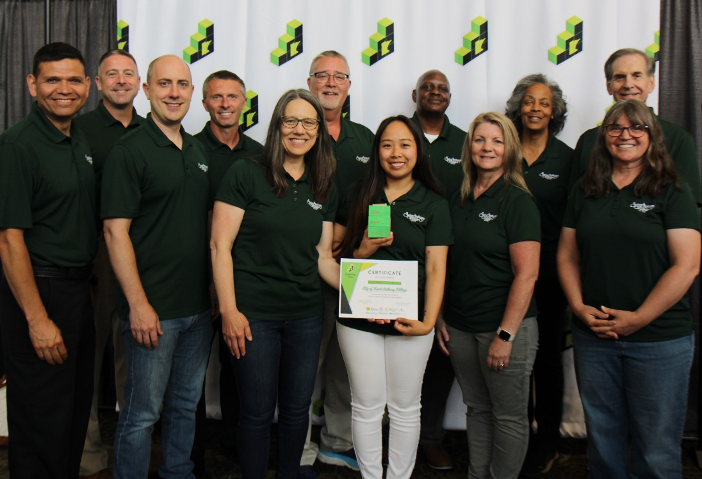
City of Saint Anthony Village receives GreenStep 2024 award.

Saint Anthony Village has worked hard to implement best practice actions in order to meet their own sustainability goals with support from the GreenStep program and their peers. Actions taken within the program focus on cost savings, energy use reduction, resource conservation, climate change, and the encouragement of civic innovation. You can learn more about Saint Anthony Village’s efforts at https://greenstep.pca.state.mn.us/city-detail/12419.

“This award is a great achievement for the City of Saint Anthony Village,” Minette continued. “And by being part of the program, Saint Anthony Village and our peers are helping to make Minnesota more resilient for the future while also helping our cities thrive economically.”

About GreenStep: Minnesota GreenStep is a voluntary challenge, assistance, and recognition program to help cities and tribal nations achieve their sustainability and quality-of-life goals. This free continuous improvement program is based upon 29 best practices that are tailored to Minnesota cities and tribal nations. More at www.MnGreenStep.org.

###

